1. Ensure the Eagle ULP directory is set as $EAGLEDIR/ulp

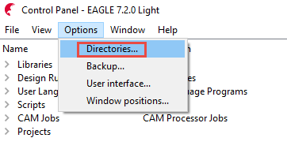

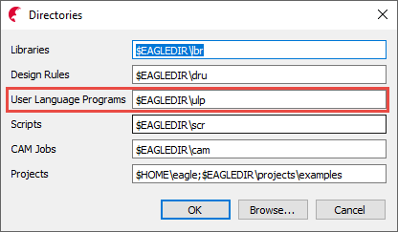

1. Run the ULP.
2. Modify the default parameters as required.
3. To save the parameters, press “Save to file” and the parameters will be saved as the name of the circuit board with the extension “.ini”. eg. If circuit board is named “raspberrypi2.brd” then the parameter file will be “raspberrypi2.ini”. The saved file will be located in the $EAGLEDIR/ulp directory. Eg. C:\EAGLE-7.2.0\ulp
4. To load previously saved parameters, “Browse” for your file and then press “Load from file”.

The parameters will be updated when the “Parameters Loaded” message box is closed.

